Sprint 2, D0018E Group 34

# User Roles:

* Employee (with a column for special sub roles like Manager/Administrator that would unlock more permissions)
* Customer

# Scenarios/Use-cases:

* Employee adds a new product
* Employee edits/deletes a product
* Employee views current orders made by customers
* Customer logs in on site and buys a product
* Customer submits a contact form
* Customer adds products into his/her shopping cart and then checks out
* Customer logs in and views his/her order
* An unregistered user makes an account

# Architecture:

* Bootstrap framework for HTML,
* PHP for the Server,
* MySQL for the database.

We will use PHP to connect the SQL Database with the HTML website, and then use that connection to export and import data to and from the server. The bootstrap framework is just to make a neat looking website while simplifying the coding process.

GitHub link to code repository: <https://github.com/Mawn/D0018E-Databaser>

# Test-case Specifications (for sprint 2 only):

* Manually add new products via the database and refresh the website to see the changes
* Add a new category to see the updates
* Change product categories on products and filter the products page to show the changes

# E-R Diagram:

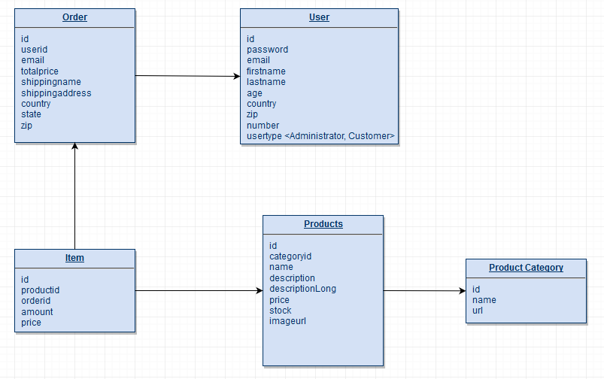

We couldn’t get MySQL Workbench to work on the school computers, so we are still using a draw.io XML Diagram for the E-R Diagram.

# Backlog:

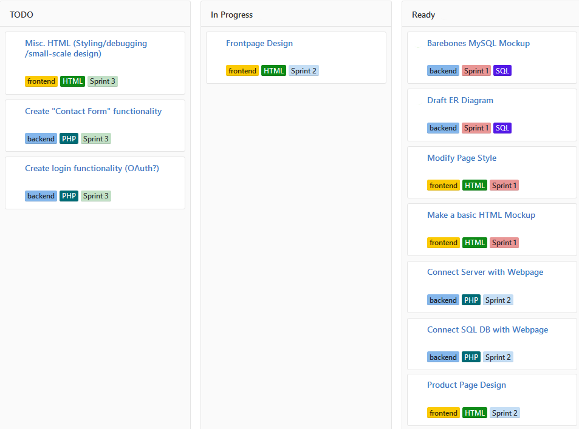

# Limitations and Improvements:

Currently you can create a new category in MySQL and a new category will appear in the html code, and while it links to the custom URL given in the “productscategory” table, you need to manually create new HTML/PHP files for it to work.